
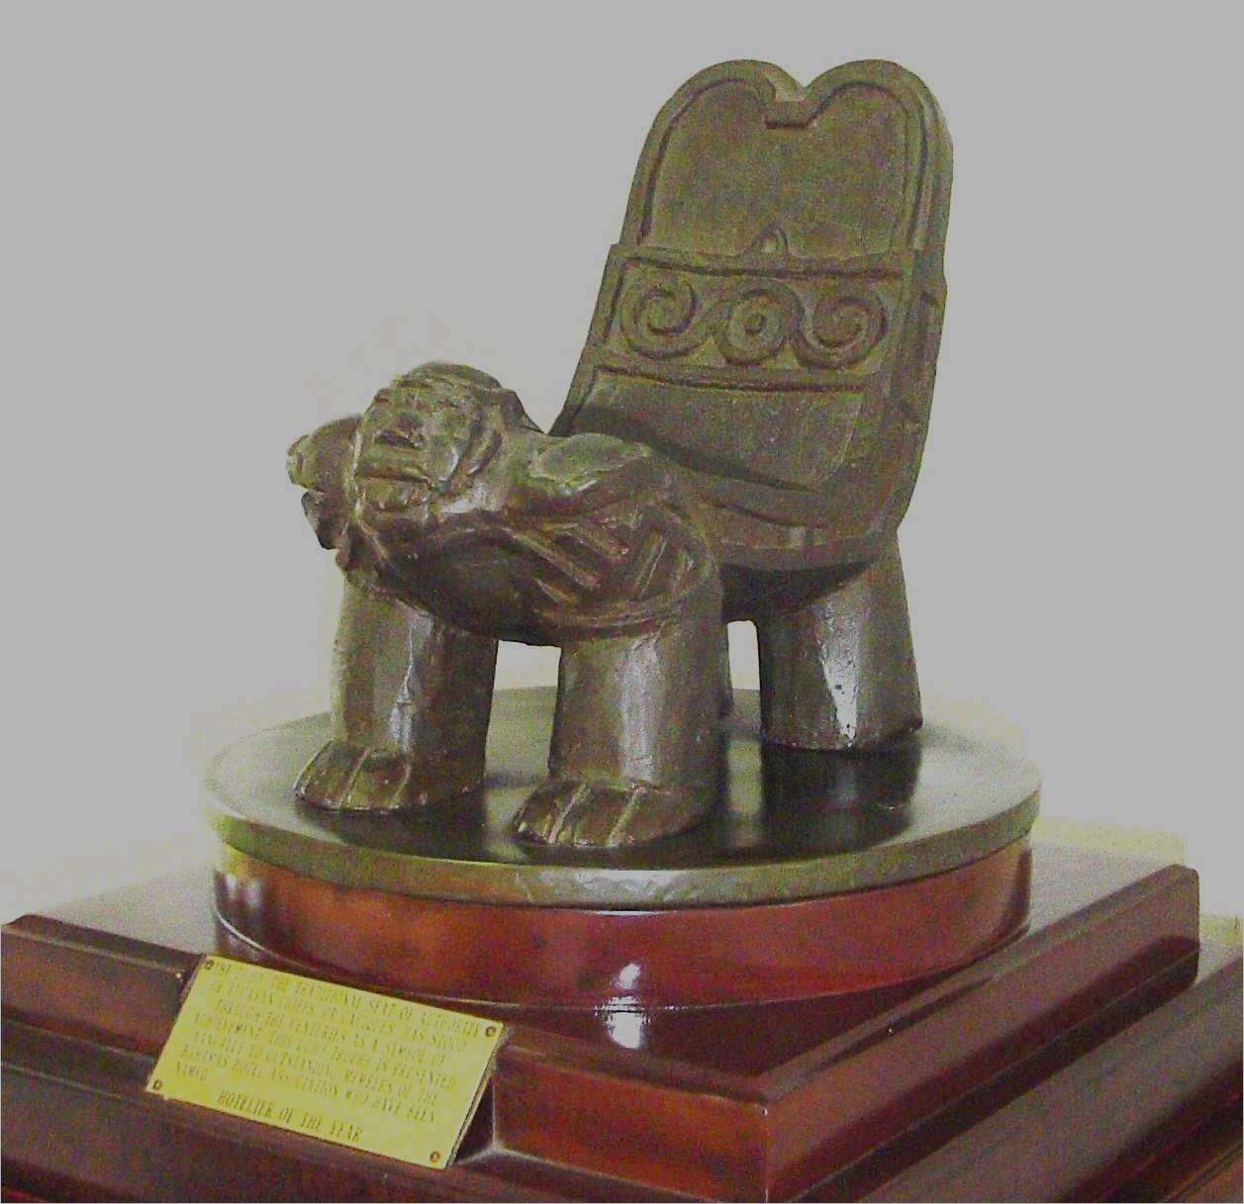

THE CACIQUE AWARDS
Manager of the Year
NOMINATION FORM

Nomination Deadline: To be received by BHA no later than August 31st, 2012
NOMINATION FORMS ARE AVAILABLE AT www.bhahotels.com

“Recognizing and Honouring the Sector’s Finest Performers!” The Cacique Awards has been established to recognize outstanding contributions to the hotel and tourism sector in The Bahamas. In choosing the winner, the selection committee will be guided by the information provided. Please provide us with very specific information. Nominees should be chosen for their consistent performance over a sustained period of time. The decision of the judges will be final.

Only Operator Members of the Bahamas Hotel Association are eligible to submit nominations. Allied members, while not eligible to nominate, are encouraged to recommend to a hotel General Manager or Human Resources Director, an outstanding employee, Manager or Chef which the hotel should consider nominating. Completed nomination forms, together with testimonial letters, two 3 x 5 studio-quality colour head and shoulder photographs, showing the nominee in normal work (uniform) or professional attire, and a resume are to be submitted to:

The Bahamas Hotel Association
The Bahamas Tourism Centre, 3rd Floor
John F. Kennedy Drive, Nassau, N.P., The Bahamas

PLEASE TYPE OR PRINT LEGIBLY

NOMINEE'S NAME:
HOTEL/ORGANIZATION:
JOB TITLE:
DEPARTMENT:
PHONE CONTACT:
EMAIL ADDRESS:

ACTIVITIES
1. Demonstrated achievement in management of hotel operations, including:
i. Operational Matters (e.g. financial, front desk operations, reservations, housekeeping, repair and maintenance, etc)

_________________________________________________________________________________________________________________________________________________________________________________________________________________________________________________________________________________________________________________________________________________________________________________________________________

ii. Food & Beverage Management (e.g. cost control, menu planning, use of Bahamian food products. restaurant decor and theme planning, etc.)

iii. Marketing (e.g. sales promotion, advertising, public relations, printed materials, etc.)

iv. Building and Grounds (e.g. innovation in improving visual appeal of property and facilities. Maintenance innovations of facilities, etc.).

v. Staff Training and Motivation (e.g. procedures/programmes undertaken to improve professional level of staff, incentive programmes, etc.).

2. Demonstrated commitment to community affairs and the promotion of local hospitality and tourism industry.

3. Demonstrated commitment to national affairs and participation in BHA activities.

- PERSONAL DEVELOPMENT RECORD SUMMARY: Please indicate any training and educational activities undertaken to further his/her personal development.

5. EMPLOYMENT HISTORY: Please give details of your nominee's employment history including the following information:

1. Date of employment: _______________________________________ 2. Length of service in present position: _________________

3. Main responsibility of present position

In addition to the above, please provide the following information:

PAST E M P LO Y M E N T H I S T O R Y
Position | Company | Date

Please provide the qualifications obtained by your nominee, the institution granting the qualification and the date obtained

PRINCIPAL ACADEMIC QUALIFICATIONS
Qualification | Institution | Date

- Membership in civic, fraternal, professional organizations, or allied industry associations.

6. Hobbies and Leisure Activities: Please give any known details of your nominee's interest and activities as they are expressed in arts, crafts and leisure activities.

Note: Additional comments or testimonials may be attached to this nomination.

Nomination submitted by:

NAME: ________________________________________________________________ TITLE: ____________________________________________________________

HOTEL/ORGANIZATION: ________________________________________________________________________________________________________________

TELEPHONE: _____________________________________________ EMAIL ADDRESS:_______________________________________________________

_________________________________________ ______________________________________
Signature of Chief Executive Date

_________________________________________ ______________________________________
Signature of Nominator Date

