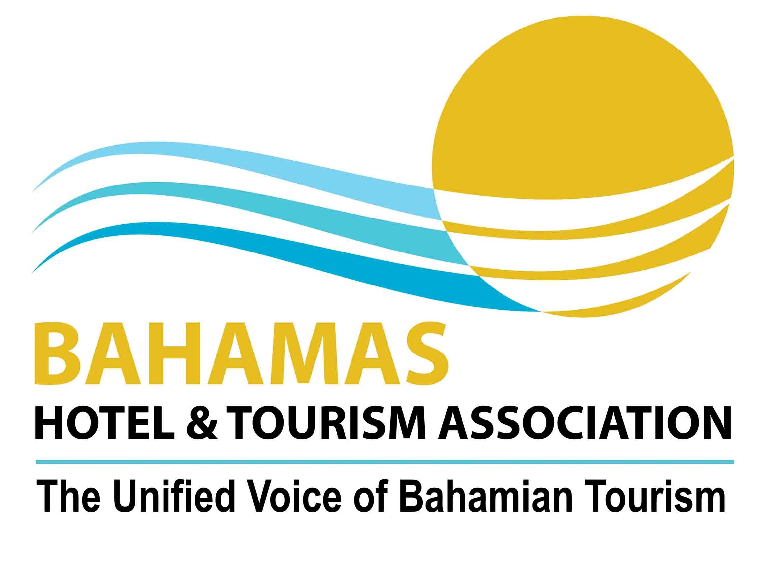
Hurricane Comin….Be Prepared
An Overview of BAHAMAS HOTEL AND TOURISM ASSOCIATION Readiness Activities and
Recommended Planning Steps for Members

While the chance in any given year of a specific island in the stretch of The Bahamas chain getting a direct hit from a strong hurricane is small, one must always be prepared. The Bahamas Hotel and Tourism Association (BHTA), working in partnership with the Ministry of Tourism, plays an important role in ensuring that the tourism industry is adequately prepared to handle the impact of hurricanes and natural disasters.

BHTA serves as the primary private sector representative on the National Emergency Management Agency’s (NEMA) tourism committee, chaired by the Ministry of Tourism. Our primary role is to serve as a communication point for the industry. In that regard, it is important that BHTA is provided with up-to-date contact information by businesses and that businesses respond promptly to BHTA’s request for information and damage assessments immediately following a storm. In this document you will find:

- An overview of BHTA’s hurricane cancellation policy,
- BHTA’s preparation plans in the event of a potential storm threat
- Basic Planning steps for members to consider (details are provided in the industry’s hurricane procedures manual)

BHTA HURRICANE CANCELLATION POLICY
BHTA maintains a Hurricane Cancellation Policy, which has been in place for a number of years. The policy considers travellers who would either need to postpone or cancel their vacation in The Bahamas due to a storm’s impact.

The agreed policy gives the vacationer a choice of using deposits or payments toward a future stay at the same property in The Bahamas, or in the event that the vacationer cannot travel to The Bahamas at all, it provides the vacationer with a full refund.

Although it is not mandatory that all hotels in The Bahamas should adopt the Hurricane Cancellation Policy, properties that are members of BHTA have been encouraged to adopt it. The Bahamas Hotel and Tourism Association also encourages hotels which are not members of the association to extend the goodwill policy to their guests. Furthermore, the BHTA encourages its members to be considerate in respect to hotel rates in cases in which guests must stay in the country beyond their original date of departure.

BHTA’s Hotel Cancellation Policy is designed to facilitate the comfort of guests as well as to protect the reputation of hotels and the destination of The Bahamas.

READINESS ACTIVITIES

Timeframe: Annually PRIOR to Start of Hurricane Season
Hotel and Tourism-Related Businesses Should….
- Appoint and Periodically Convene an Emergency Coordinating Committee or similar mechanism – with representation from all major areas of the company to plan and guide implementation of the company’s established disaster readiness and response plan. If a plan is not in place one should be established, drawing on the recommendation in this overview, as well as, a detailed recommendations as presented in the Hurricane Procedures Manual
- Insurance Assessment - Review policy to ensure levels and types of coverage meet anticipated needs. For guidance, refer to BHTA Allied Member Smith Orloff’s advisory shared with BHTA members annually prior to the start of the hurricane season. Smith Orloff is available to conduct a complimentary general review of BHTA member’s existing policy to ascertain degree of coverage and offer recommendations.
- Structural Assessment – Check buildings and grounds for structural defects, and vulnerability to wind or water damage, particularly roofs and sealing around windows and doors. Repair or correct problems before the hurricane season.
- Sustainability Measures – Each year businesses should incorporate continued improvements to their property which will help to minimize storm damage, ease the restoration period, and return your business to normal as quickly as possible. Decisions regarding the design of grounds and facilities, landscaping, staff readiness and response training, alternative energy and water sources, waste consumption and disposal mitigation --- should be reviewed annually and resources budgeted accordingly.
Annually, BHTA will….
- Update all communications records (emails, Bahamas land and mobile lines, satellite phones, overseas contact info if available) for primary and where available secondary contacts for: tourism-related businesses and members, airlines, NEMA tourism committee members.
- Review Annual Readiness Plans – including standard communications documents, information technology readiness, facility needs.
- Participate in Pre-season Readiness Meetings with the NEMA tourism committee.
- Update Readiness Information Provided to Members
- Send Readiness Information to Members prior to June 1 start of season.

TIMEFRAME: 96 Hours Before a Possible Hurricane…
Communications
BHTA will….
- Provide members via email with twice daily storm updates (referred to as BHTA’s Eye on the Storm) showing coordinates and projected path.
Businesses will be advised that…
- Management should review preparation plans and begin to think about the possibility of enactment. The business should have in place an Emergency Coordinating Committee or similar mechanism – with representation from all major areas of the company. They should meet at this time to discuss preliminary plans.

TIMEFRAME: 72 Hours Before a Possible Hurricane…
Communications
BHTA will…
- Provide Eye on the Storm email bulletins continue to be forwarded twice daily to members.
- BHTA and Ministry of Tourism activate Emergency Preparedness and Response Team, holding initial conference call with all key parties including representatives from the Promotion Boards, the Family Island tourism offices, and others. Storm status and initial plans are discussed.
Members are advised that…
- If your property can accommodate more guests contact BHTA to provide the number of additional guests you can accommodate and what the charges will be

Logistical Plans
BHTA will…
- Advise members to activate their preparedness plans, engaging all employees. The plan should include a review of all vulnerable areas, inventory (particularly of items to assist with initial clean up), supplies, fuel, batteries, flashlights, generators, drinking water, non-perishable foods, securing and backing up important data and records, etc.
Members are advised that…
- They should inventory their supplies to determine that their property has enough water, food, flashlights and first aid equipment. Should they have a generator, make sure that they tap up their tanks with gas or diesel. Order food and water supplies if necessary
Staffing
Members are advised that…
- A managers meeting should be held, with all key managers and members of the internal Emergency Coordinating Committee or similar mechanism to discuss plans and develop internal communications list for distribution. A key person and alternative should be identified to liaise with guests.
- A roster should be developed and tentative plans made for those who will stay on the premises throughout the storm and possibly beyond. Consideration should be given to provide accommodations to immediate family of staff, if possible, who will be staying on the premises.
Guest Relations
Members are advised that…
- Hotels should inform guests of the potential threat and advice of options, indicating that should they stay on the island where you would intend for them to be (on property, another property, shelter) during and after the storm. The property’s hurricane policy should be communicated to all guests.
- Contact pending arrivals to your property to inform them of the weather conditions and should the storm’s arrival be imminent, ask them to postpone their arrival until the passing of the storm.
- Preliminary arrangements should be made to identify guests who may need assistance with early departure transportation arrangements in the event they wish to leave.
- Prepare hurricane emergency procedures (memo, disclaimer letter and outline of procedures appropriate for your property should be on file) to ready for distribution to guests.

Timeframe: 48 Hours Before a Possible Hurricane…
Communications
BHTA will…
- Send hotel and allied members a copy of the Hurricane Damage Assessment Form, with instructions to complete the form and get the information to BHTA within 24 hours after the storm passes.
- Eye on the Storm email bulletins continue to be forwarded at least twice daily to members.
- BHTA and Ministry of Tourism emergency preparedness and response team meet twice daily via conference call to finalize plans and ensure all lines of communication are in place. This will continue as long as is necessary.
- Readiness plans kick in with Ministry of Tourism to activate Command Center at British Colonial Hilton.
- Industry and all partners are provided with copies of media and travel partner updates developed cooperatively by the Ministry of Tourism and BHTA. BHTA advises the industry that it is best to have reports to the media regarding the status of the storm and impact channeled through the Director General’s Office, Ministry of Tourism or the BHTA Executive Vice President.
- Coordinate with airports and airlines to determine scheduling changes and begin to communicate such to members.
Logistical Plans
Members are advised that…
- Operators and other members should be putting plans in place. Grounds should be canvassed to remove potential hazards from trees and vegetation and unsecured materials. Important equipment or supplies which are exposed or potentially exposed should be secured and protected. Drains should be cleared, vehicles should be fueled up and fuel secured for generators and equipment.
Staffing
Members are advised that…
- Staff meetings should be held to communicate the status and review policies and procedures which they need to be familiar with.
- Rostering information is shared with staff and arrangements made to try to accommodate any special circumstances.
Guest Relations
Members are advised that…
- Hotels should communicate with guests to inform them of the potential threat and advise of options, indicating provisions should they stay on the island where you would intend for them to be (on property, another property, shelter) during and after the storm. Guests are advised of the likelihood of closing of the airport and any US customs and immigration facilities with reopening anticipated as quickly as possible based upon the severity of the storm.
- They should be in communication with their airlines to understand flight adjustments which may be necessary.
- The property’s hurricane policy should be communicated to all guests. The property’s hurricane emergency procedures (memo, disclaimer letter and outline of procedures appropriate for your property should be on file) should be distributed to guests.
- Inform your guests how meal service will be provided during and after the storm. Tell them what time the storm is expected to have impact and how you would like them to prepare
- Arrangements should be made for guests who may need assistance with early departure transportation arrangements in the event they wish to leave. While it is left up to the operator to consider at what point compensation or evacuation policy should take effect, this should be clearly communicated in the memo and disclaimer letter.
- Properties should keep a Guest list with the following information:
  - The number of Hotel Guest
  - Names of the guest
  - Home addresses and contacts in the event of an emergency
  - Medical Problems if any

24 Hours Before a Possible Hurricane…
BHTA will…
- Distribute list of key emergency contacts for BHTA, the Ministry of Tourism, NEMA officials, and others.
- Continue to provide members with tracking and status updates, and other important information.
Logistical Plans
Members are advised that…
- All unsecured property, furniture, equipment, plants, etc. should be secured.
- Areas subject to flooding, water or wind damage should be secured.
- Arrangements, if necessary, should be made for onsite shelters if appropriate and areas where guests and staff could be secured during the storm. These areas should include bedding and water and food to last at least three days.
- All vital records should be backed up and secured.
Staffing
Members are advised that…
- Staff meetings should be held to continue to ensure strong lines of communication and resolve any problems which may arise.
- Special activities may be planned for guests to keep them preoccupied during the storm.
Guest Relations
Members are advised that...
- Guests are presented with any final information regarding possible evacuation, shelters, and pending closing of airport.
- Guests are advised regarding precautions and reminded of the property’s hurricane emergency procedures.
- Should you not be able to accommodate your guest in your hotel, guests will then need to be accommodated at a shelter. The Government and the Red Cross will inform the hotel Association of the appropriate shelter (s) available to us and the time of their opening
- The following items should be in place to be able to provide for your guest…
  - Bedding….Towels, pillows, sheets etc..
  - Water…enough for at least 3 days (2-3 gallons)
  - Food….enough for three days – sandwiches, munchies etc..

24 Hours after a Storm…
Members are advised that…
- As soon as possible after the storm has passed complete and return to BHTA or the Ministry of Tourism representative on your island a Damage Assessment Report. Provide details on any damages, the numbers of rooms that you have available, any injuries to your guests, when you estimate being able to take relief workers and be open for tourism.
- BHTA and MOT will inform NEMA of the initial assessment and room status should there be a need for relief workers to be accommodated. Tourists who are staying at properties will have first priority in being housed at less damaged hotels.
BHTA will…
- Provide updated information on airport openings, US Preclearance, and revised airline schedules.
- Work with the Ministry of Tourism to provide a general statement to the press and travel partners indicating the impact on tourism-related facilities and readiness to accept business.
- Follow up with all hotels and key attractions to secure Damage Assessment Reports

48 Hours after a Storm…
BHTA will…
- Compile the results of the Damage Assessment Reports and prepare a communication for the Government and NEMA. If necessary, will advise Government on the extent of need for an Exigency Order providing tax/duty relief for repairs.
- Advise properties with severe damage as indicated in their damage assessment report of assistance available regarding their insurance claims and possible Government Exigency Order relief.

FOR ADDITIONAL INFORMATION ABOUT PLANNING AND RECOVERY…AN EXCELLENT RESOURCE TO HELP….
The Hurricane Procedures Manual developed by the Caribbean Hotel Association and the Caribbean Tourism Organization provides detailed information and advice to assist hotels, and in a practical sense – all businesses, with having in place a sound plan. To receive a copy of the Manual (members - $25; nonmember - $50), contact the Bahamas Hotel and Tourism Association at 242-502-4200.

